Design and Analysis of Algorithm

Lab Experiment-2

V.GOVARSHAN
CH.SC.U4CSE24210
07.12.2025

1)Bubble sort

Code:
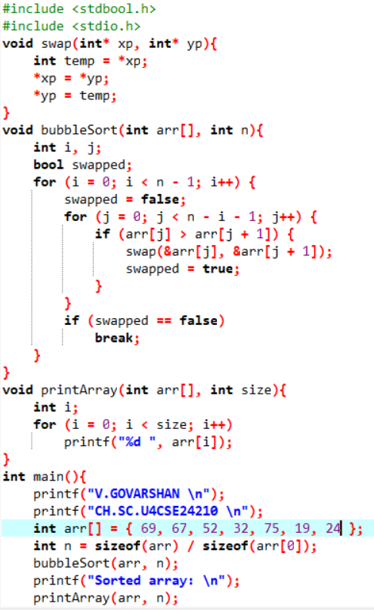
Output:
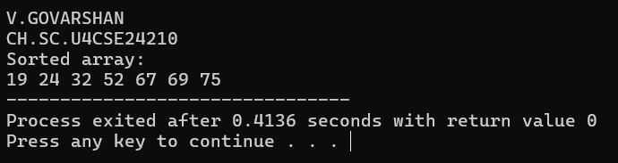
Interpretation:
by finding the adjacent maximum values we can sort the array layer by layer when the outer loop ends, we will get the sorted array

2) Insertion Sort
Code:
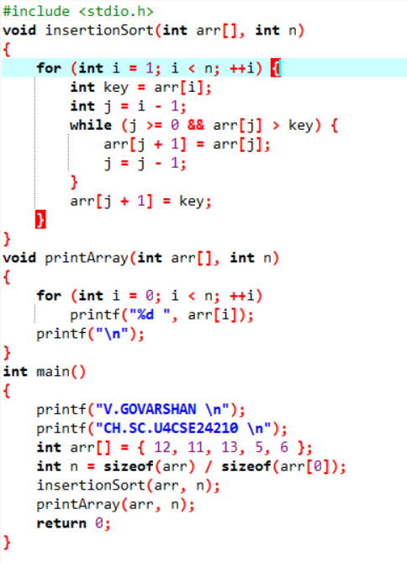
Output:
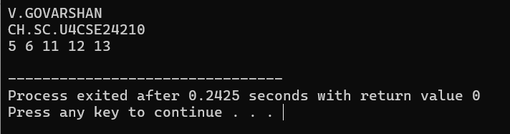

Interpretation:
pick a element by iterating the loop and place in their respective sorted index by swapping

3) Selection Sort
Code:
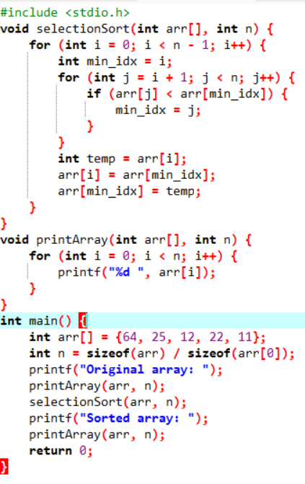
Output:
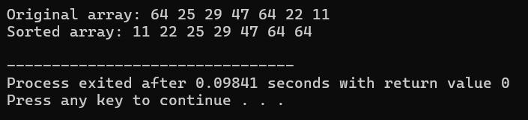
Interpretation:
“Find the smallest number and place it first.
Then find the next smallest and place it second, continue until the array is sorted

4) Bucket
Code:
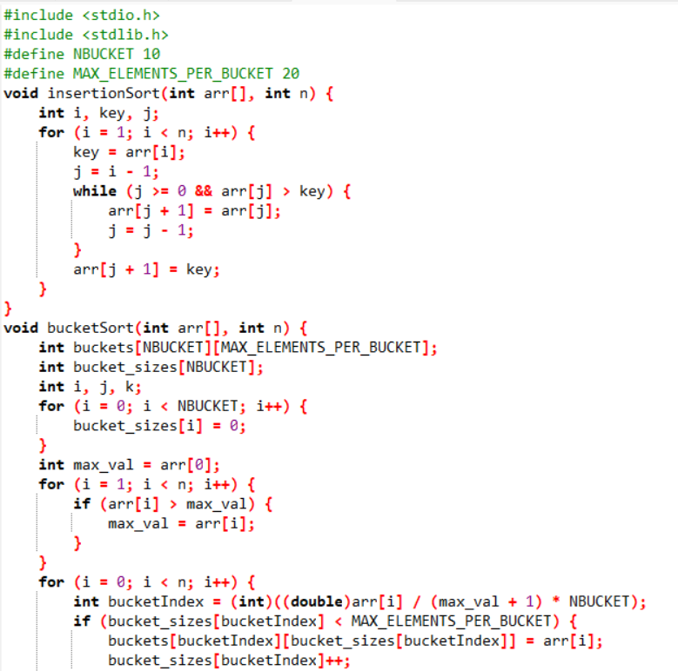
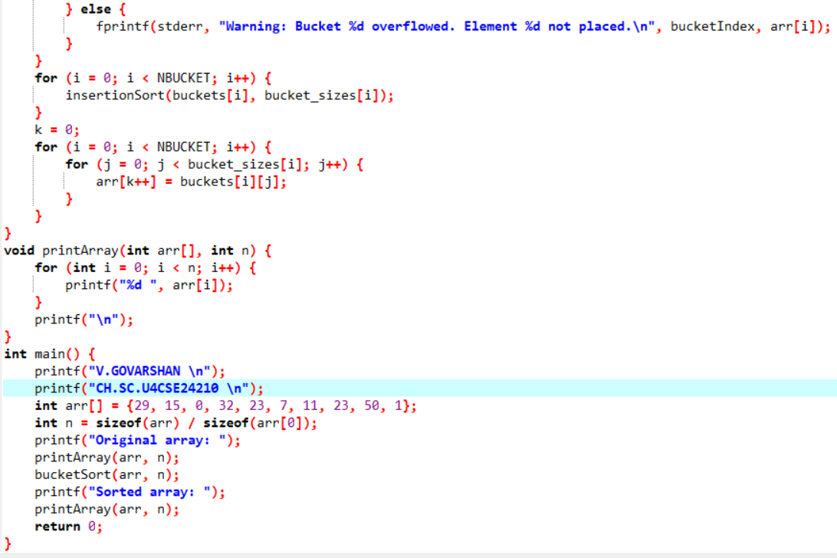
Output:
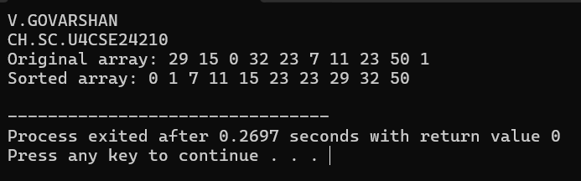

Interpretation:
Group similar numbers together in buckets ,then read the buckets in order you get a sorted array

5)Heap Sort
Code:
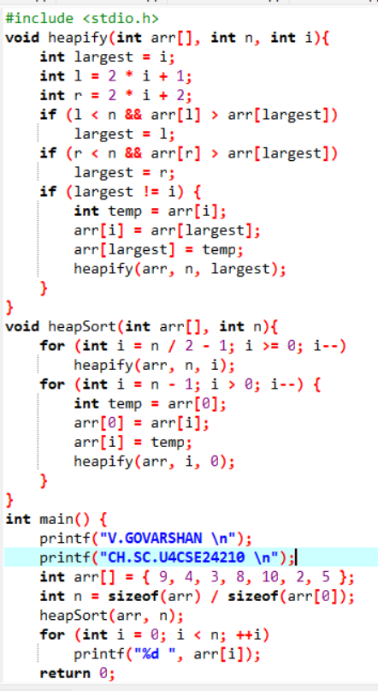
Output
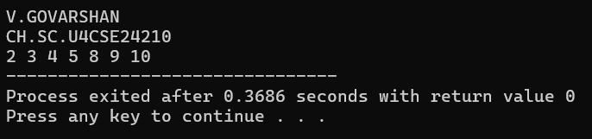
Interpretation:
Heap sort first builds a max-heap, so the largest element comes to the top,
then repeatedly removes the top element and places it at the end of the array.
This produces a sorted array

